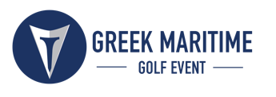
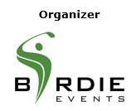

PRESS RELEASE

Greek Maritime Golf Event:
Best golf tournament in Greece

For the 8th year, on September 8-11, 2022

Athens, April 12, 2022 – The Greek Maritime Golf Event, retains its top position, as the best golf tournament in Greece, while it is expected to gather the interest of the Greek and world maritime industry for the 8th year, on September 8-11, 2022, at Costa Navarino, Messinia.

According to the most significant institution for the promotion of best sports marketing practices in Greece, the Sports Marketing Awards, the Greek Maritime Golf Event stood out for its innovation and distinction in the Greek market. More specifically, the tournament won 3 Bronze Awards, one in the “Individual Sports (Golf)” category for the Greek Maritime Golf Event held at Costa Navarino and two more in the “Best Covid 19 Response” category as one of the three best event responses in the Covid-19 era and “Best Strategy for Product / Service Launch” for the sponsorship of Samsung Electronic Hellas, in the Glyfada Maritime Golf Event tournament that took place at the Golf Course of Glyfada.

In the context of this year’s awards, the organizer, representative of Birdie Events and recognized Greek PGA golfer, Mr. Thanos Karantzias highlighted: “It is important for the history of this tournament that the efforts we make to promote the sport of golf in Greece and to connect the maritime industry with sports are recognized. We are very proud that these three new accolades at the Sports Marketing Awards bring us once again on the top of golf events in Greece. We continue in full force, and we are waiting for you in September at Costa Navarino”.

Enjoy a video with some of the highlights from last year’s tournament and get ready for this year’s event, here: https://youtu.be/cAD-v4HIHbI

This year’s golf action
More than 80 leading executives from the maritime industry forming 20 teams of four, will have the opportunity to play for the first time in the two new 18-hole signature golf courses, The Hills Course and International Olympic Academy Golf Course. Participants will compete on a team level on Friday, September 9, in the two (2) ball better ball (3/4 hcp) at The Hills Course. Respectively, on Saturday, September 10, they will take part in a shotgun scramble that will take place at the International Olympic Academy Golf Course.

“Battle” for the first positions
Participating teams will claim significant prizes for the top three positions in the overall standings; whereas special awards will be given to individual players who will achieve the best scores in the “Longest Drive” and “Closest to the Pin” categories.

IRI/The Marshall Islands Registry is the event’s Platinum Sponsor.
Mainline Shipping Company and Jotun Hellas are Golden Sponsors.
DNV and Arrow Hellas are the Silver Sponsors.
Aon is the Official Supporter.
Boo Productions is the Audio Visual Partner.

Greek Maritime Golf Event, is organized by Birdie Events, through an initiative of the recognized Greek PGA golfer, Mr. Thanos Karantzias. The award-winning sports marketing agency of ActiveMedia Group has undertaken the event’s Golf Production. The tournament is addressed exclusively to distinguished executives of the Greek shipping community.

The event will be held under the auspices of the Ministry of Tourism and the Hellenic Golf Federation.

More information about the schedule of this year’s event and the unforgettable moments that golfers will experience during the tournament, will be announced in the coming weeks.

Hashtags: #greekmaritimegolfevent #costavarino #navarinohills

Information for the Greek Maritime Golf Event:
website: www.greekmaritimegolf.gr
e-mail: info@greekmaritimegolf.gr

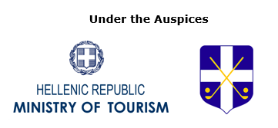

Information for the editors:
ActiveMedia Group Press Office:
tel.: +30 210 9343020, fax: +30 210 9316505
e-mail: pr@activemedia.gr

